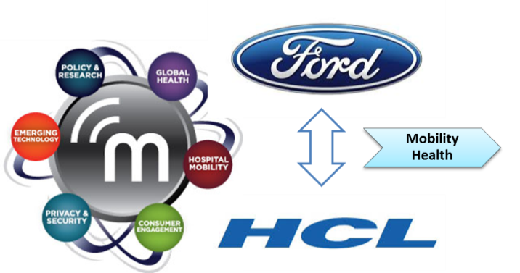

|  |
| --- |
| HCL Technologies Ltd. |
| Ford SUMURR mHealth – Phase 3 Feature set |
|  |

# Solution Overview

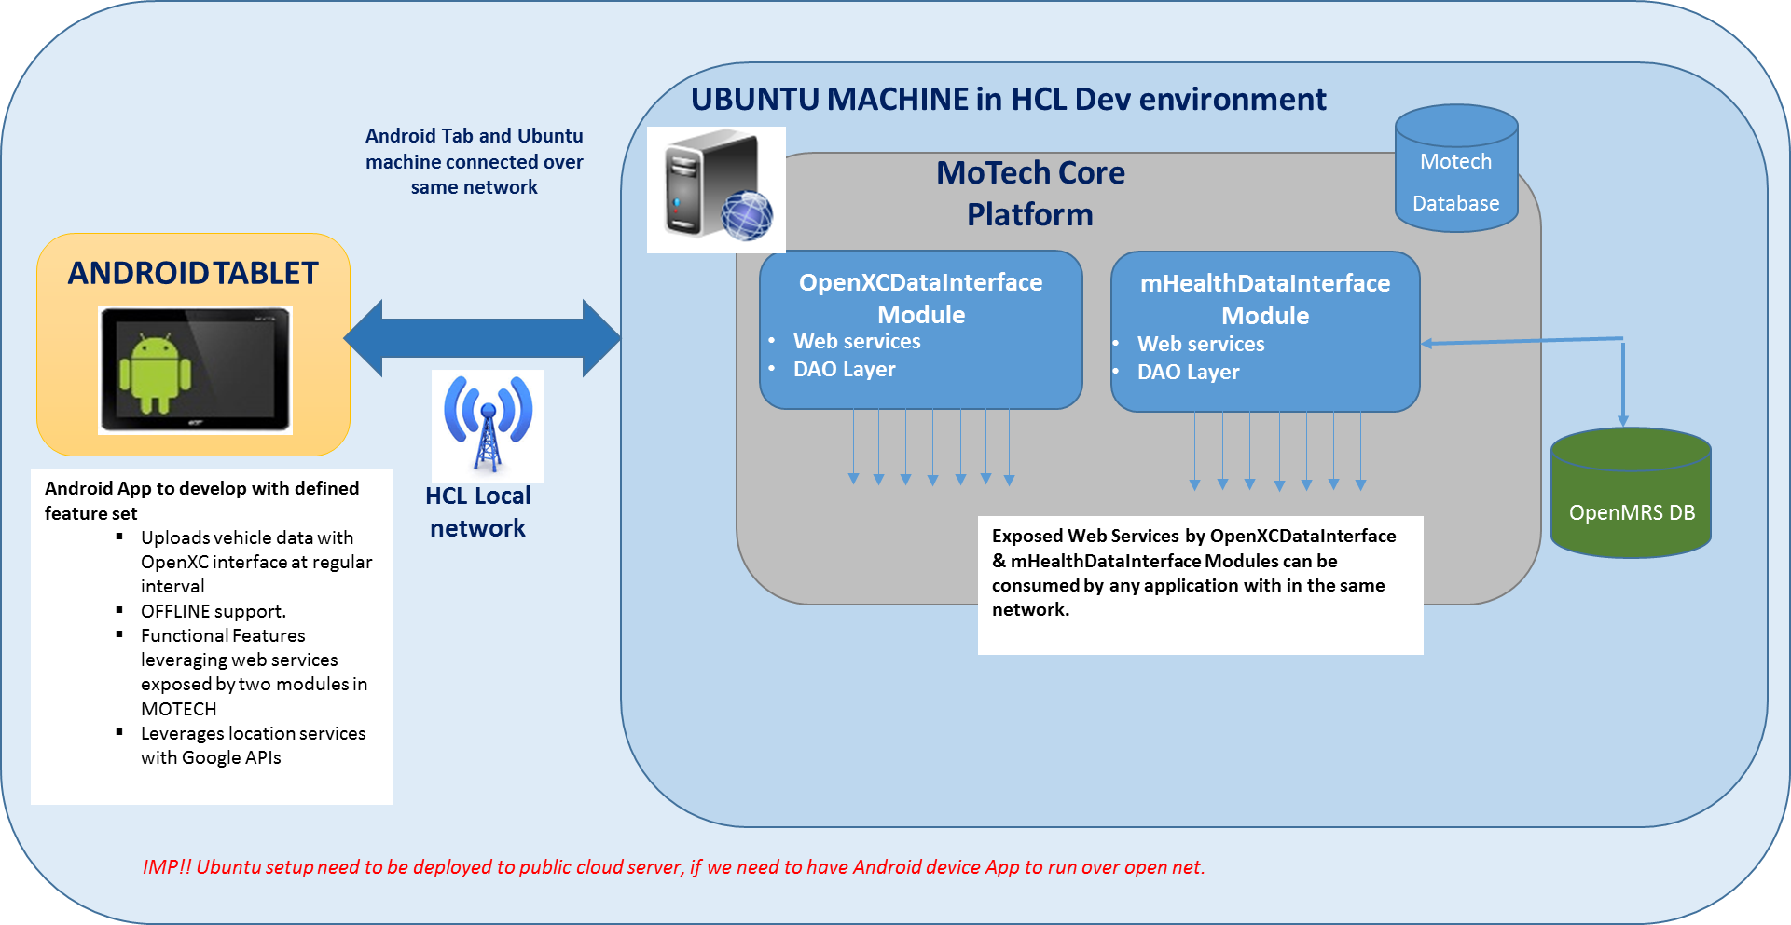Diagram on overall integrated solution –

**Highlights on above framework –**

* Two modules named as **mHealthDataInterface** and **OpenXCDataInterface** are integrated in the MOTECH Backend framework.
* The MOTECH system deployed on a single server machine
* Both modules expose the APIs in form of web-services for other apps to consume – for vehicle data as well as for patient & health worked data.
* The Mobile App based on an Android device is written to interface with the MOTECH Backend via APIs exposed from both the new modules *mhealthDataInterface* and*OpenXCDataInterface*
* In the local development environment of HCL, both MOTECH server machine and Mobile device are connected to same network, which is internal network of HCL.
* ***To have the Mobile App running and accessing the MOTECH backend through public network (internet, it will be necessary to deploy the MOTECH setup on a public cloud server (AWS, Azure,...)***

# Android App as a Demo-able Application

In phase 3 of Ford Mobility Health project, we plan to develop a mobile application based on Android platform, which will talk to back-end services of the two modules that are developed as being part of MOTECH framework. And demonstrate certain functional feature set or use cases.

Thus the app will represent an end to end functional flow of some of the features of mHealth system that are being leveraged via the web interfaces that are provided by two modules developed as part of this project – OpenXCDataInterface Module and mHealthDataInterface Module.

**The App is supposed to run in a phone that is with health worker in the Ford mHealth vehicle.**

The set of key features to be developed in Android App are mentioned in below sections –

## Startup Splash Screen and vehicle registration to backend

On startup app will show up a splash screen like below –

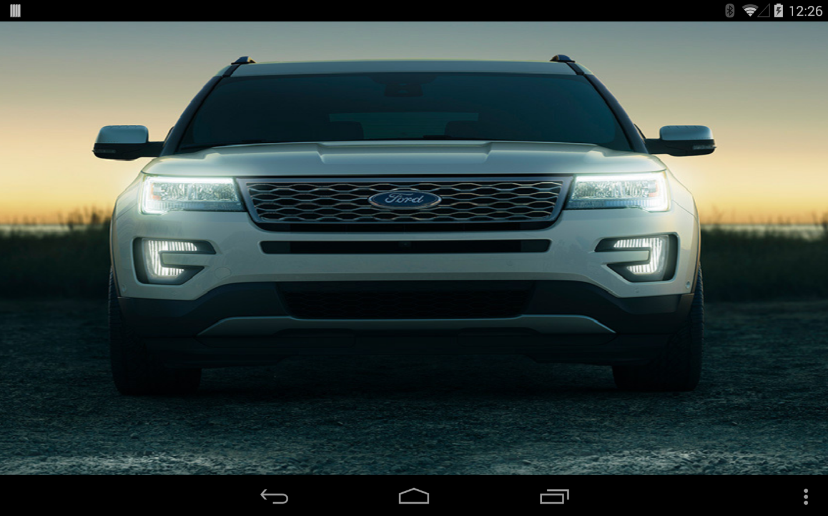

**Fig. Splash screen of App on start up**

The App will do the vehicle registration with OpenXCDataInterface module, which will be only first time of execution.

## Offline Feature Support

The App will implement the OFFLINE mode support while it uploads the vehicle real-time data to MOTECH Backend.

**Key objective of feature is track the vehicle status from MOTECH server even for the duration when cellular network is lost at vehicle location.**

The App will keep monitoring on the cellular network status of phone. If signal is not available, vehicle data that is candidate for upload is put in a local cache of phone.

App will detect as cellular network is re-connected, on the same it will sync up with backend server via sending all the data packets that are in cache.

**At present – upload interval (though customizable) is kept @ every 30 sec. 1 packet.**

The local cache on phone is created to hold the data for 1 hour that is a total of 120 packets capacity. Again this count and hence duration is easily customizable.

If cache is full, the oldest packet will be replaced by newest packet.

Thus feature will allow to track the vehicle for the last up to one hour duration whenever the cellular signal is re-stored. Of course if vehicle is having no signal for more than 1 hr, then tracking will be lost for additional duration.

## Dashboard

General Layout of the screen is Tab based layout. There are FOUR Tabs developed at present –

* Dashboard
* Nearby mHealth Patients
* Nearby mHealth Vehicles
* Fetch Details of Patients & Notify Patients

Dashboard is the first Tab, which will display a snapshot of vehicle status (real time data through OpenXC interface) and upload status to server.

A tentative layout of screen is as below –

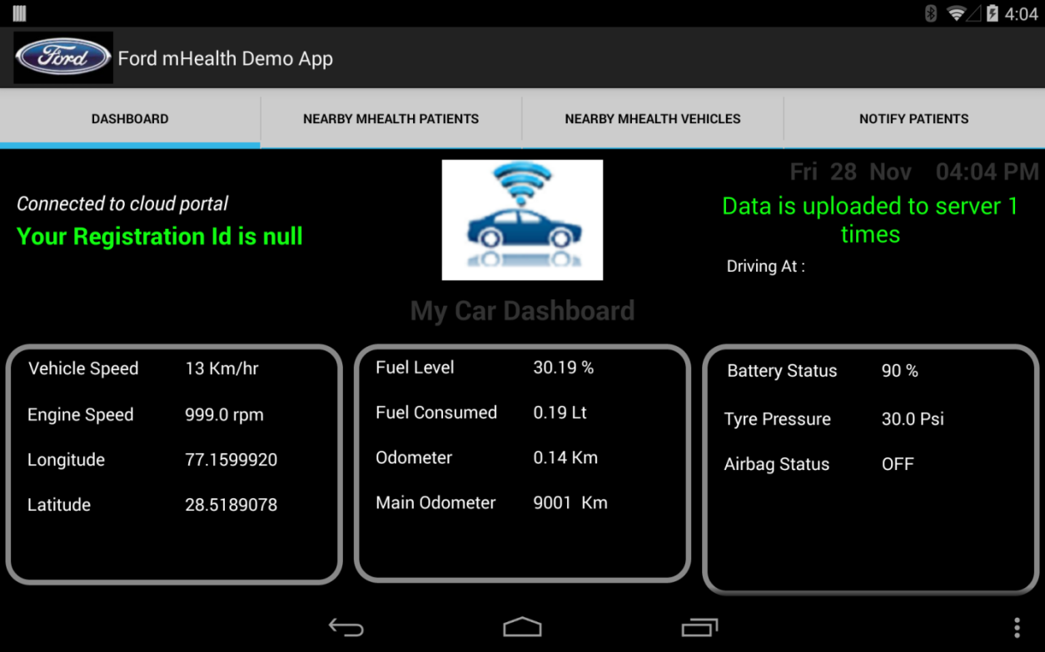

The Backend API that is being used in this screen is Data Upload API.

## Vehicle Location tracking

Vehicle Location tracking is the feature that will display the location of current vehicle as well as other mHealth vehicles on the map.

A tentative layout of screen is as below –

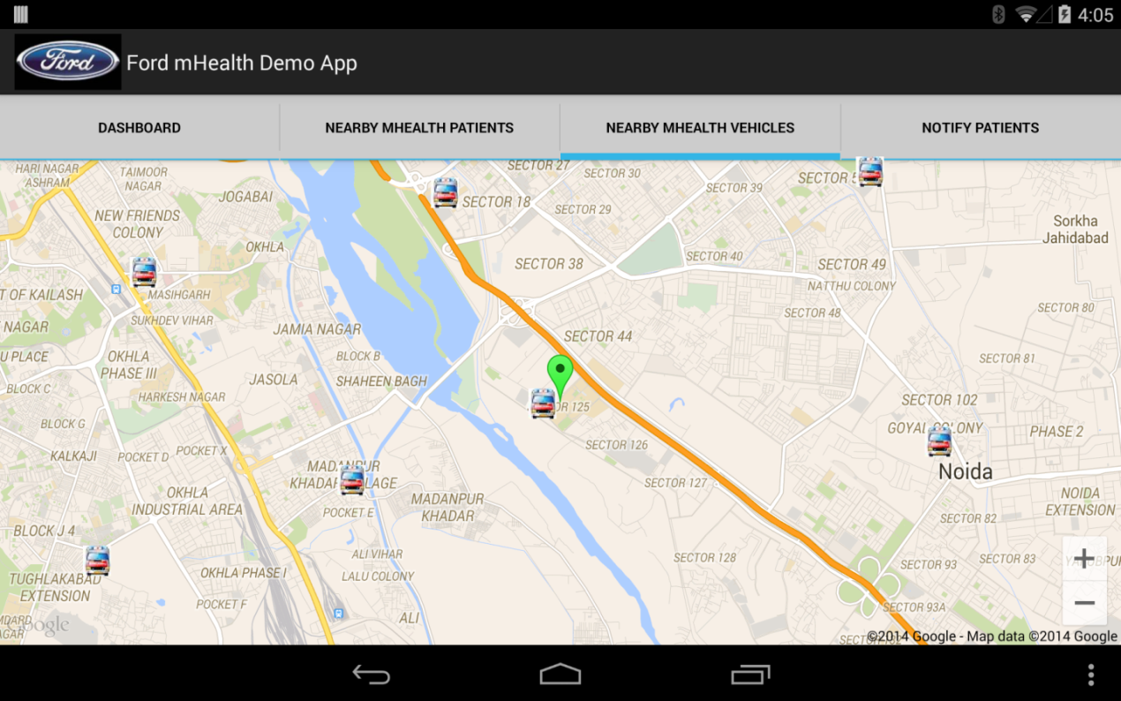

## Patient location tracking vs vehicle location

This will show up the registered patients that belong to the postal code location where vehicle is driving at present. That means it will show up nearby patients to vehicle, which will be probable set of patients whom health worker is going to visit.

A tentative layout of screen is as below –

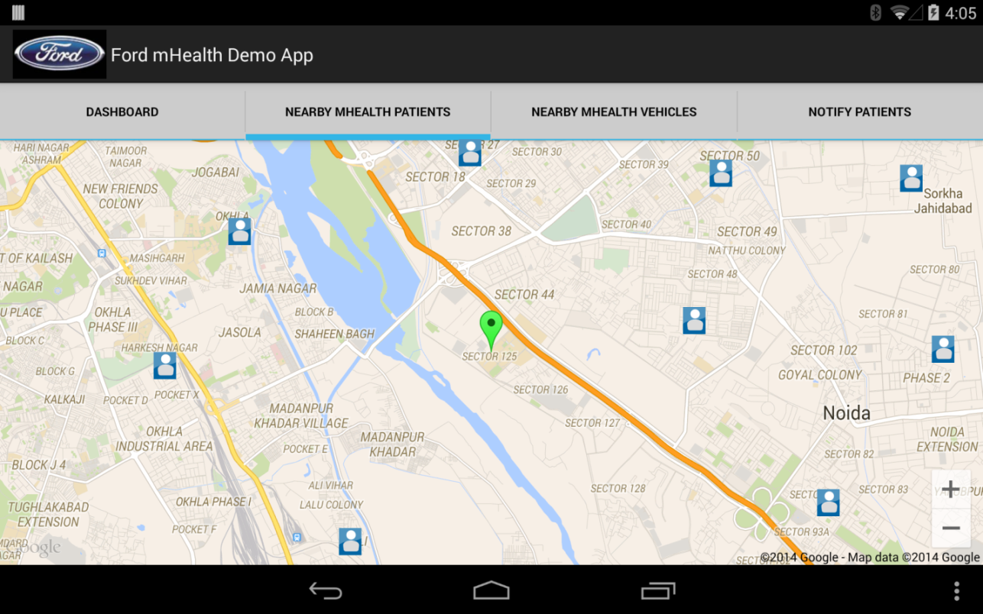

## Notification message to patients for Health Worker visit

This is an interesting feature where App will send an SMS message to registered mobile no of patient(s), whom health worker is going to visit shortly.

While being on the way, it will display the list of registered patients on current postal code. Health worker then can select some/all patients and send the message notification to them stating that HW is visiting shortly to them, for they could be available and ready for meeting.

A tentative layout of screen is as below –

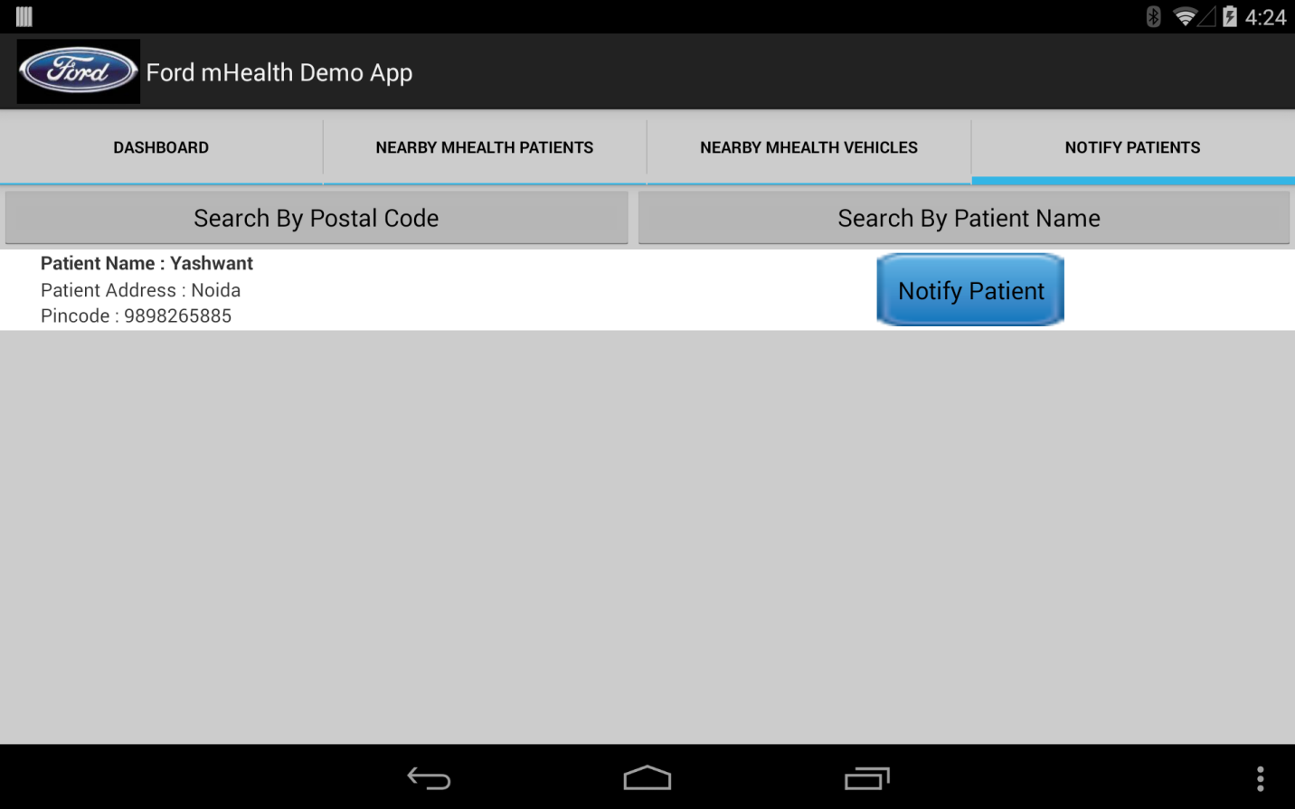

***As prerequisite – we will use the SIM card service of cellular provider that is plugged on the Android phone/tab.***

# Prerequisite for Demo/Test run of Solution

Below prerequisite for Ford / any external unit to run the Solution –

1. **MOTECH backend setup to be deployed on a public network which could be AWS, Azure or any public cloud service provider. Ford and HCL need to make due provision to ensure this.**
2. Android Device (phone or Tab)
   1. Connected to internet either via wifi or cellular network.
   2. Should have size 5” or more.
   3. For SMS notification, it must have active SIM connected

**~~ end of doc ~~**